NAME: K Yamini
REG NO: 192572181

Write a Python program to solve the 8–Puzzle problem using Breadth First Search (BFS).
Aim:
To solve the 8–Puzzle problem using Breadth First Search and display the steps to reach the goal state.
Algorithm:
- Define the goal state of the puzzle.
- Take the initial state as input.
- Find the position of the blank tile (0).
- Create a queue to store puzzle states (BFS approach).
- Add the initial state into the queue.
- Maintain a list to store visited states.
- Repeat the following until the queue is empty:
a. Remove the front state from the queue.
b. Check if it is the goal state.
c. If yes, stop and return solution.
- Generate all possible moves of the blank tile:
  - Move Up
  - Move Down
  - Move Left
  - Move Right
- For each new state:
a. Check if it is already visited.
b. If not, add it to the queue.
- Print all steps from initial state to goal state.
Python Code:
from collections import deque

# Goal state
goal = [[1,2,3],
[4,5,6],
[7,8,0]]

# Function to find blank position
def find_zero(state):
for i in range(3):
for j in range(3):
if state[i][j] == 0:
return i, j

# Function to print state
def print_state(state):
for row in state:
print(row)
print()

# BFS function
def solve_puzzle(start):
queue = deque()
visited = []

queue.append((start, []))
visited.append(start)

while queue:
current, path = queue.popleft()

if current == goal:
return path

x, y = find_zero(current)

moves = [(0,1),(1,0),(0,-1),(-1,0)]

for dx, dy in moves:
nx, ny = x + dx, y + dy

if 0 <= nx < 3 and 0 <= ny < 3:
new_state = [row[:] for row in current]

new_state[x][y], new_state[nx][ny] = new_state[nx][ny], new_state[x][y]

if new_state not in visited:
visited.append(new_state)
queue.append((new_state, path + [new_state]))

# Input
start = [[1,2,3],
[4,0,6],
[7,5,8]]

# Solve
solution = solve_puzzle(start)

# Output
print("Initial State:")
print_state(start)

print("Steps to reach Goal:\n")

step = 1
for s in solution:
print("Step", step)

if step == 1:
print("# Move blank (0) DOWN")
elif step == 2:
print("# Move blank (0) RIGHT")

print_state(s)
step += 1

print("Goal Reached Successfully!")
Input:
Initial State:
1 2 3
4 0 6
7 5 8

Output :
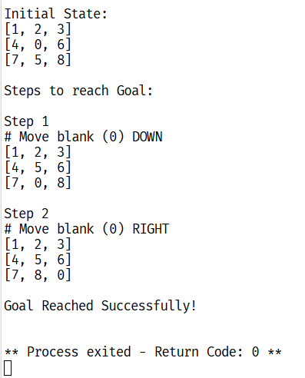
Result:
The 8–Puzzle problem is solved successfully using Breadth First Search, and the goal state is reached with step-by-step output.

